Learn to ride

High-quality **Western and English** riding lessons focusing on safety and including instruction o horse care, saddling a horse, and aspects of horesenanship.

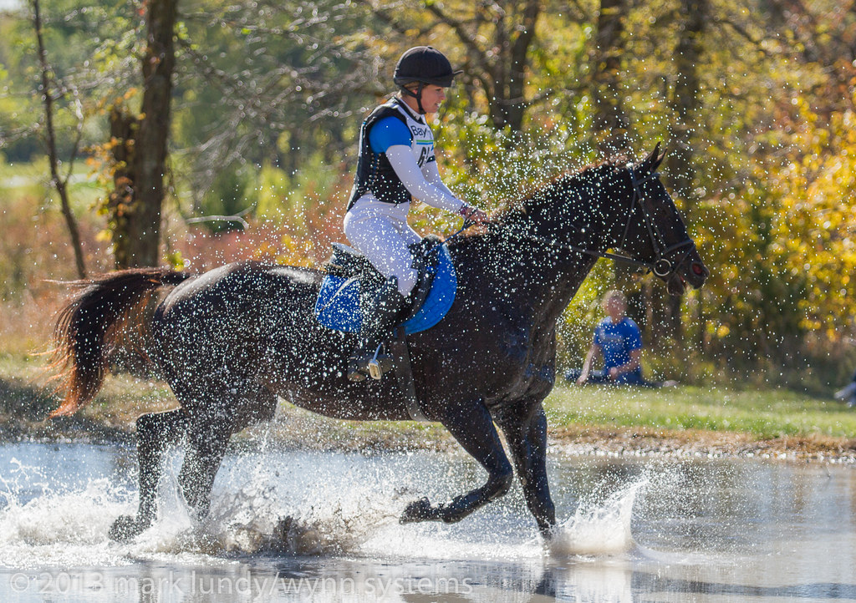

* Novice to advanced instruction for children and adult
* Indoor and outdoor arenas
* $40 per hours for private lessons $25 for group lessons

Call TRI-VALLEY AT 555-2030 TODAY!